Game Design Document

Fill up the Following document

1. Write the title of your project.

The Adventures of the Duo

1. What is the goal of the game?

The goal is to choose the correct options to beat the boss in his throne room

1. Write a brief story of your game?

In the game, there is a young boy called Jack and his friend Tom. They go on adventures in the forests, cities and eventually find the castle of the evil Lord Tumber. Jack must find a way in the castle or he will die to the guards or traps set by the evil tyrant. He will find an over powered sword and must use it to beat Tumber.

1. Which are the playing characters of this game?

* Playing characters are the ones which respond to the user based on the input from the user
* Cars, monkeys, dinos, wizards etc, are the playing characters in the game.

|  |  |  |
| --- | --- | --- |
| Number | Character Name | What can this character do? |
| 1 | tom | He is the main character and chooses the options to continue the story |
| 2 |  |  |
| 3 |  |  |
| 4 |  |  |
| 5 |  |  |
| 6 |  |  |
| 7 |  |  |
| 8 |  |  |

1. Which are the Non Playing Characters of this game?

* Non Playing characters are the ones which don't have an action or a behaviour when the user interacts with the game.
* Hurdles, stones, bananas, coins, etc are non playing characters in the game.

|  |  |  |
| --- | --- | --- |
| Number | Character Name | What can this character do? |
| 1 | jack | He is tom’s friend and asks him questions on what to do |
| 2 | Lord Tumber | He is the evil ruler of the earth who tom and jack intend to defeat. |
| 3 |  |  |
| 4 |  |  |
| 5 |  |  |
| 6 |  |  |
| 7 |  |  |
| 8 |  |  |

Draw your imagination of this game. What does this game look like?

* Draw the game either on your computer or on paper,
* Add images of scenes of the game to show each of the playing and non-playing characters at least once.

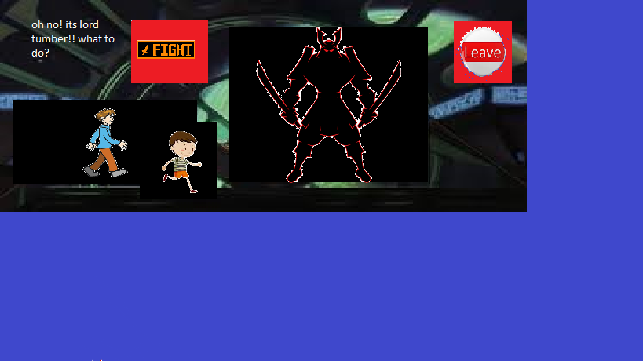

How do you plan to make your game engaging?

The game is made engaging by the weird choices and mysterious adventures of the duo.